DataBase - SQL query
*** Assessment ***

Qua.1 -> | Write SQL query to solve the problem given below  Consider three table named as city, customer and country The city table is given below :
 | 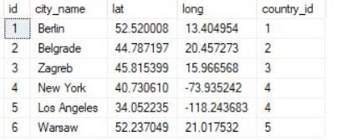
 | The Customer table :
 | 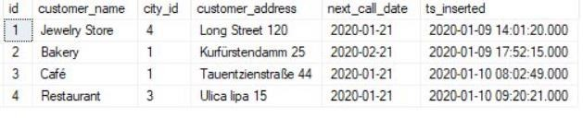
 | The Country table :
 | 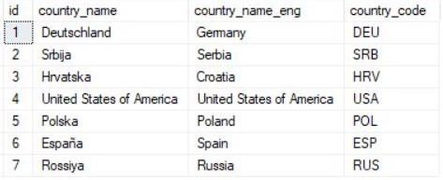
Note :
- While each city has a related country, not all countries have related cities (Spain & Russia don’t have them)
- Same stands for the customers. Each customer has the city_id value defined, but
only 3 cities are being used (Berlin, Zagreb & New York) Now commute the following tasks :
Task : 1 (join multiple tables using left join)
List all Countries and customers related to these countries.

For each country displaying its name in English, the name of the city customer is located in as well as the name of the customer.
Return even countries without related cities and customers.
Task : 2 (join multiple tables using both left and inner join)
Return the list of all countries that have pairs(exclude countries which are not referenced by any city). For such pairs return all customers.
Return even pairs of not having a single customer Make sure to make your code clean neat
Ans.  TABLE 1  city | CREATE TABLE city (  id INT PRIMARY KEY,  city_name VARCHAR(100), lat DECIMAL(10, 7),  lon DECIMAL(10, 7),  country_id INT  );
INSERT INTO city VALUES
(1, 'Berlin', 52.520008, 13.404954, 1),
(2, 'Belgrade', 44.787197, 20.457273, 2),
(3, 'Zagreb', 45.815399, 15.966568, 3),
(4, 'New York', 40.730610, -73.935242, 4),
(5, 'Los Angeles', 34.052235, -118.243683, 4),
(6, 'Warsaw', 52.237049, 21.017532, 5);
 | 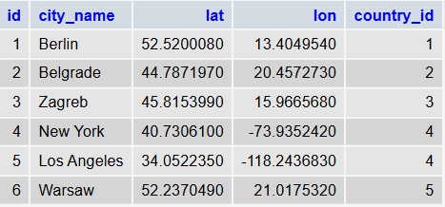
TABLE 2  customer | CREATE TABLE customer (  id INT PRIMARY KEY,  customer_name VARCHAR(100), city_id INT  );
INSERT INTO customer VALUES (1, 'Jewelry Store', 4),
(2, 'Bakery', 1),
(3, 'Café', 1),
(4, 'Restaurant', 3);

 | 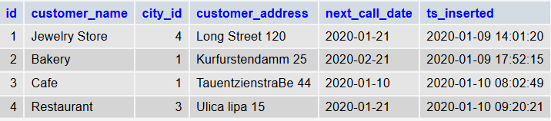
TABLE 3  country | CREATE TABLE country (  id INT PRIMARY KEY,  country_name VARCHAR(100)  );
INSERT INTO country VALUES (1, 'Germany'),
(2, 'Serbia'),
(3, 'Croatia'),
(4, 'United States'),
(5, 'Poland'),
(6, 'Spain'),
(7, 'Russia');
 | 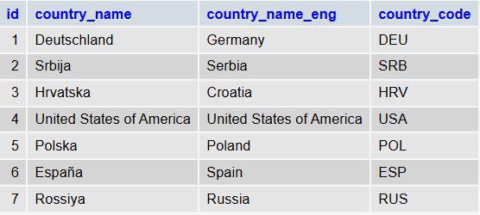
Task : 1 | (join multiple tables using left join)  List all Countries and customers related to these countries.  For each country displaying its name in English, the name of the city customer is located in as well as the name of the customer.  Return even countries without related cities and customers.
SELECT
country.country_name_eng AS country, city.city_name AS city, customer.customer_name AS customer
FROM
country

LEFT JOIN city ON country.id = city.country_id
LEFT JOIN customer ON city.id = customer.city_id;
 | 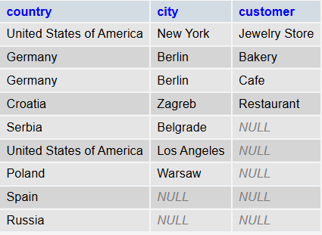
Task : 2 | (join multiple tables using both left and inner join)  Return the list of all countries that have pairs(exclude countries which are not referenced by any city). For such pairs return all customers.  Return even pairs of not having a single customer Make sure to make your code clean neat
SELECT
country.country_name_eng AS country, city.city_name AS city, customer.customer_name AS customer
FROM
country
INNER JOIN city ON country.id = city.country_id LEFT JOIN customer ON city.id = customer.city_id;
 | 